SPSS Installation Instructions for macOS
Official URL: https://services.smsu.edu/TDClient/180/Portal/KB/Article/8955/SPSS-Installation-Instructions-for-macOS
Category: Knowledge Base > Information Technology Services > Software and Applications > SPSS Installation Instructions for macOS
Tags: mac, spss, macOS, spss-Installation, ibm-spss
_____________________________________________________

Overview
Follow the instructions in this article to install SPSS on macOS successfully. These steps will guide you through downloading, installing, and activating SPSS on your Mac.
- Navigate to the folder sent to your email.
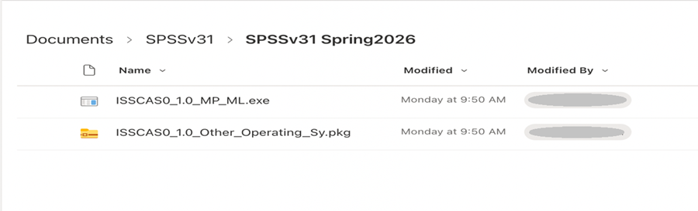
Figure 1: Folder containing the SPSS installation files sent by email
- Click on the ‘…’ and Select “Download”
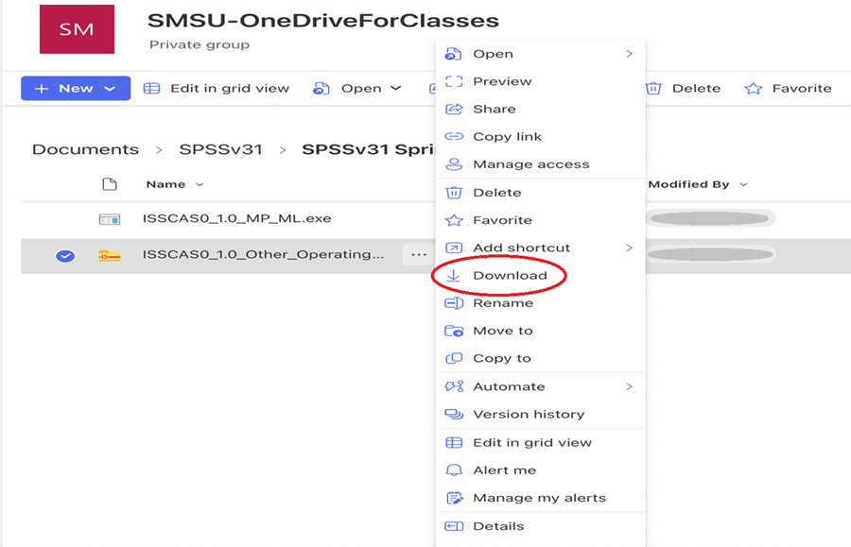
Figure 2: Menu showing three-dot options with ‘Download’ selected.
- Once downloaded, click on the file and it should bring up the installation screen. Select “continue”
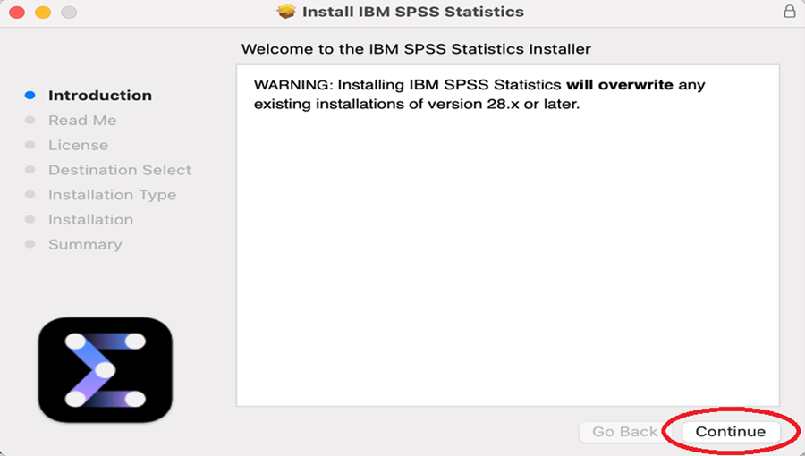
Figure 3: SPSS installer window displaying the ‘Continue’ button during setup
- Select “continue”
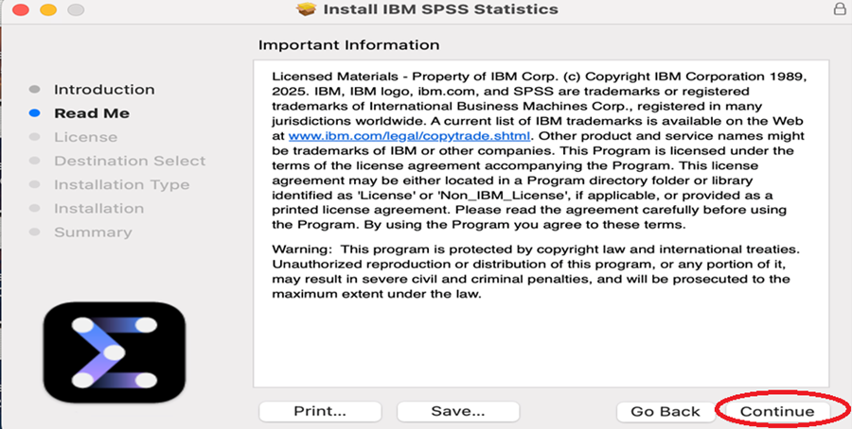
Figure 4: Installation screen prompting user to continue setup process
- Select “continue”
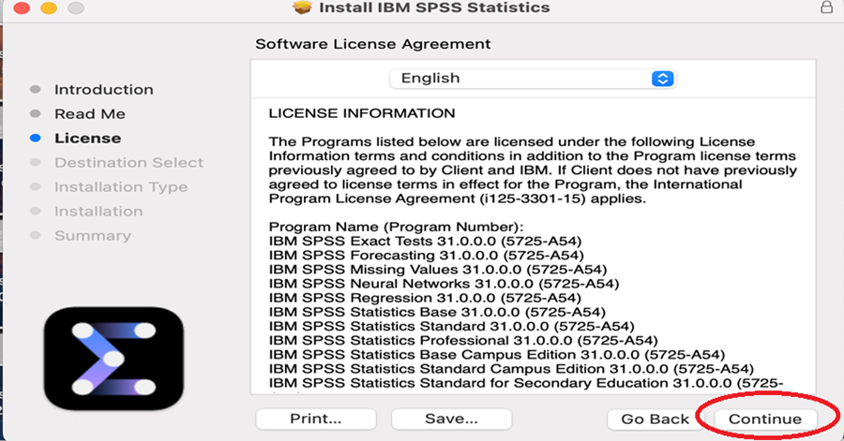
Figure 5: Installer screen asking user to review and proceed with installation steps.
- Select “Agree”
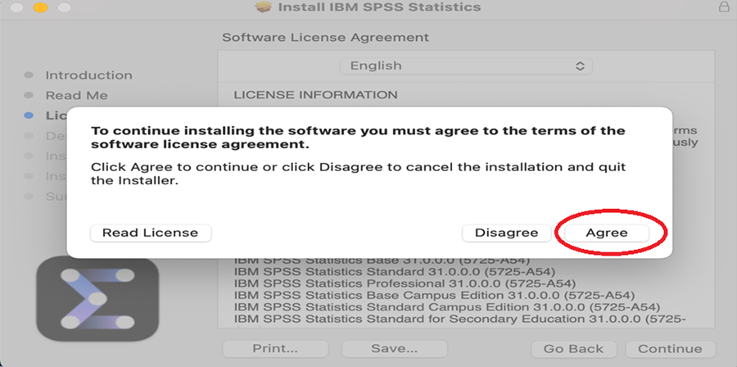
Figure 6: License agreement screen with ‘Agree’ button selected
- Select “install”
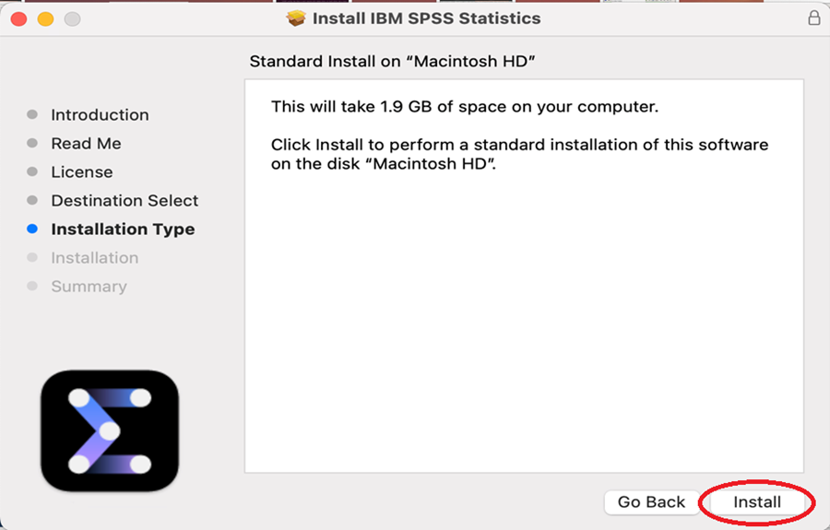
Figure 7: Installation confirmation screen showing ‘Install’ button
- Wait for the installation to finish and open the application once installed. Launch IBM SPSS Statistics
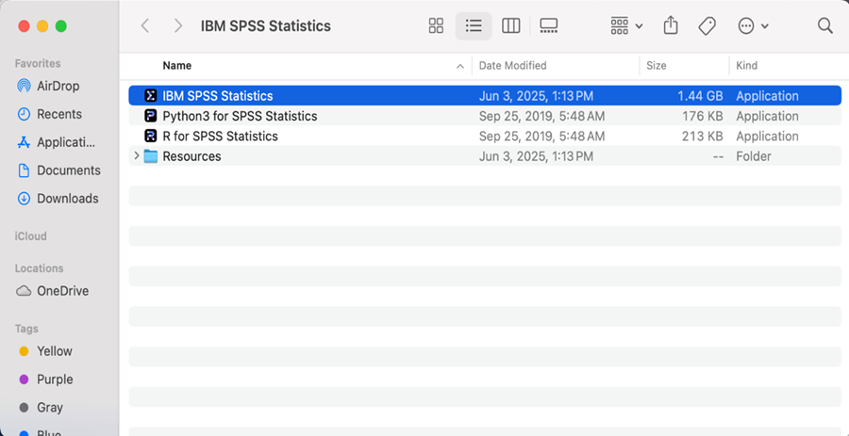
Figure 8: Progress screen indicating SPSS installation is in progress
- Select “Launch License Wizard”
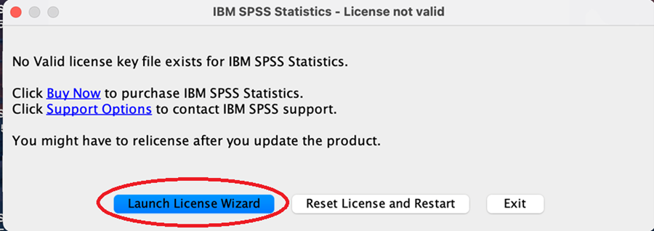
Figure 9: SPSS application launch screen showing ‘Launch License Wizard’ option
- Select “Authorized user license.”click on next”
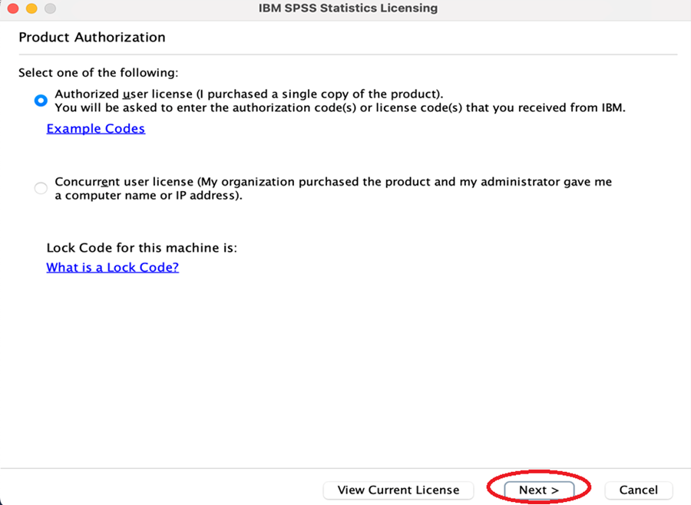
Figure 10: License wizard screen with ‘Authorized user license’ option selected
- Enter the activation code sent to you. Select “add”
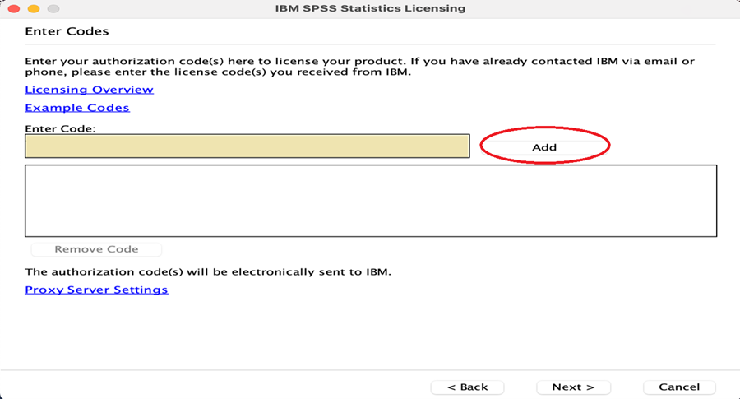
Figure 11: Activation screen prompting user to enter license code.
- This will move the code to the bottom box. Select “Next”
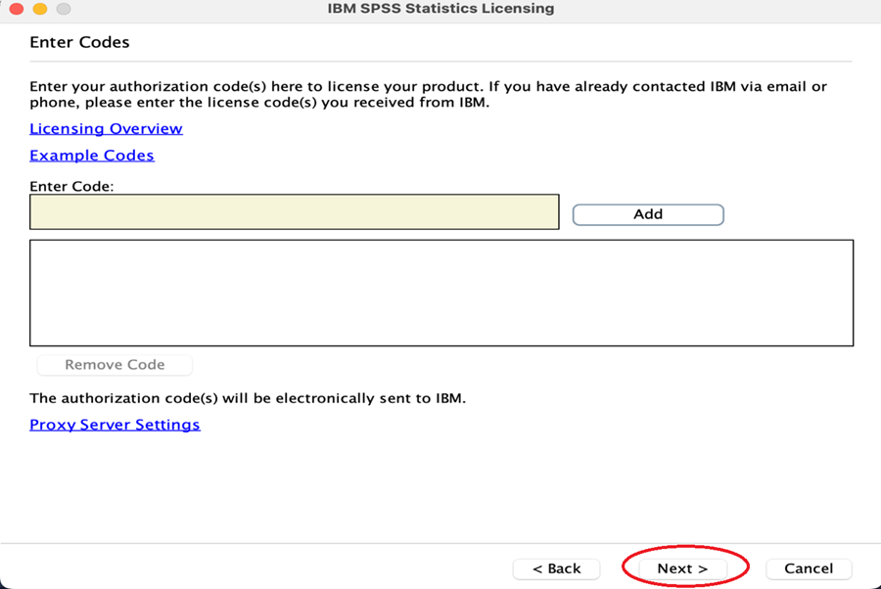
Figure 12: License code added to list with ‘Next’ button selected
- Select “Next”
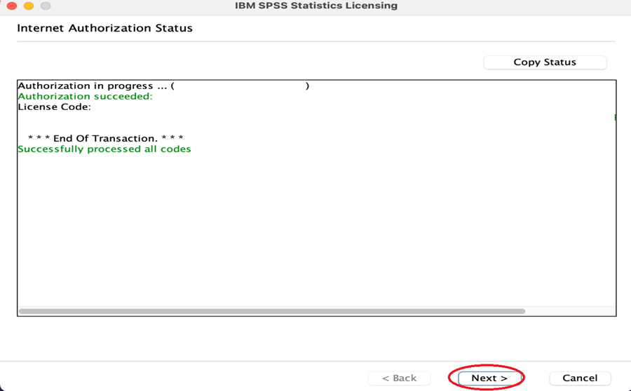
Figure 13: Final setup screen prompting user to proceed to completion.
- Select “Finish”
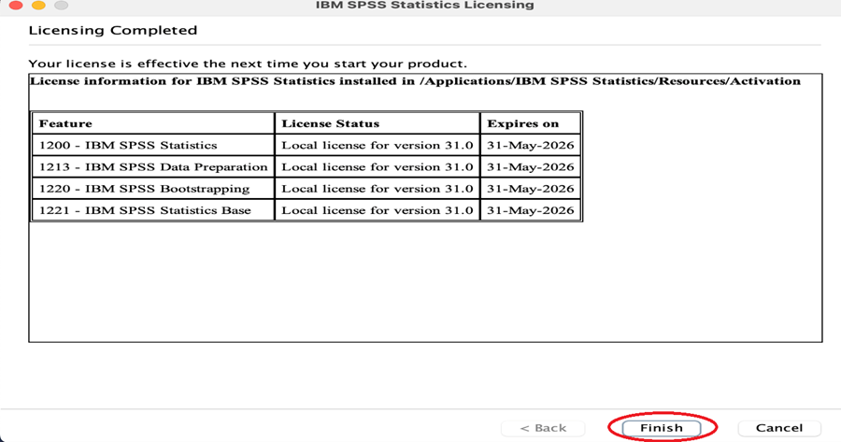
Figure 14: Installation complete screen with ‘Finish’ button displayed

Accessibility Review & Update Log:
- [x] Content accuracy and link integrity verified
- [x] High-contrast visual hierarchy implemented (Inter and Calibri)
- [x] Image alt-text captions verified (all screenshots captioned)
- [x] PDF attachments scraped and fully inlined directly inside the document
- [x] Outline headers and standard list sequences optimized for screen readers

